National Vocational Certificate level 4, in
(Electrical Technology)
“Building Electrician - Solar PV System Technician”

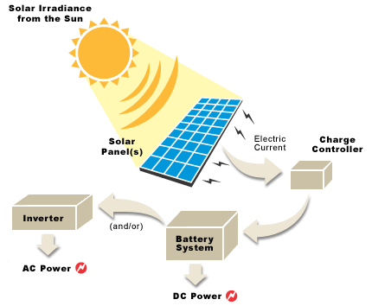
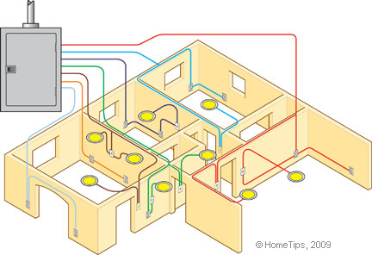

National Vocational and Technical Training Commission (NAVTTC)
Government of Pakistan

TABLE OF CONTENTS

Contents
1. TITLES OF QUALIFICATIONS 3
2. INTRODUCTION 3
3. PURPOSE OF THE QUALIFICATION 8
4. MAIN OBJECTIVES OF THE QUALIFICATION 9
5. DATE OF VALIDATION 9
6. CODES OF QUALIFICATIONS 9
7. MEMBERS OF QUALIFICATIONS DEVELOPMENT COMMITTEE 10
8. ENTRY REQUIREMENTS 11
9. REGULATIONS FOR THE QUALIFICATION 12
10. SUMMARY OF COMPETENCY STANDARDS 14
Competency Standard A: Conduct site assessment for solar PV system installation 17
Competency Standard B: Develop basic Solar PV System design 20
Competency Standard C: Interpret job document 23
Competency Standard D: Install Solar PV System 25
Competency Standard E: Perform wiring of Solar PV System 29
Competency Standard F: Troubleshoot Solar PV system 33
Competency Standard G: Maintain Solar PV system 36
Competency Standard H: Adopt safety precautions 39
Competency Standard I: Develop basic professional skills 42
COMPLETE LIST OF TOOLS AND EQUIPMENT 47

TITLES OF QUALIFICATIONS

- National Vocational Certificate level 1, in (Electrical Technology) “Building Electrician - Solar PV System Technician”

- National Vocational Certificate level 2, in (Electrical Technology) “Building Electrician - Solar PV System Technician”

- National Vocational Certificate level 3, in (Electrical Technology) “Building Electrician - Solar PV System Technician”

- National Vocational Certificate level 4, in (Electrical Technology) “Building Electrician - Solar PV System Technician”

INTRODUCTION

Solar energy has been making headlines across the world for the last few years. The global installed capacity of solar photovoltaic (PV), also termed solar cells, has grown from 5GW to more than 400GW. This phenomenal success owes to wide-ranging factors; most importantly, conducive policies, technological advancements and economy of scale. Solar PV system is now becoming financially competitive with conventional forms of power generation. Dubai, for example, is currently developing an 800MW through solar PV project with a power purchase agreement signed at less than three US cents per kW hour.

Solar radiation, or level of sunshine, is the resource or fuel for solar energy systems. Accurate measurement and analysis of this resource are fundamental to achieve the anticipated performance. However, there are other important parameters that also need to be taken into account to predict and evaluate a system’s performance and this is often where mistakes are made.

The solar industry of Pakistan has nearly doubled in size every year for the past five years, and this trend is expected to continue in future, so there are opportunities for how to become a Solar PV Technician.

Solar PV System Technician determines the design of the array and performs the installations. The process to become a Solar PV System Technician mostly depends on where an individual wants to install residential solar systems. Internationally becoming a solar energy professional sometimes requires a license specific to solar PV installment. Pakistan regulates its own solar installation and safety processes, it might be different from other world rules and regulations, hence required no license but a certificate in this qualification can provide ample of employment opportunities.

The qualification of Building Electrician – Solar PV System Technician is developed based on solar energy sector’s demand on the pattern of competency based training under national vocational qualification framework (NVQF). It carries a learning volume of 1000 hours i.e. 6 hours per day and five days a week means 33.4 weeks which is almost 8 months and four months is recommended as internship.

Solar PV System Technician plays a vital role in the installation and maintenance of Solar PV System and Electrical appliances. The increased use of solar energy has maximize the demand of Solar PV Technician having the skills to install and maintain solar photovoltaic systems, thus, meeting the ever-growing demand of industry. This course has been design and developed to achieve its objectives of providing appropriate skills. The pass out of this course would be able to:

- Work in small & big construction units as Solar PV Technician
- Work as building electrician in an electrical outfit / company / organization
- Work as building electrician with construction contractor
- Be self employed by having own electrical / wiring workshop

Training in the course is based on defined competency standards, which are industry oriented. The traditional role of a trainer changes and shifts towards the facilitation of training. A trainer encourages and assists trainees to learn for themselves. Trainees are likely to work in groups (pairs) and all doing something different. Some are doing practical tasks in the workshop, some writing, some not even in the classroom or workshop but in another part of the building using specialist equipment, working on computers doing research on the Internet or the library. As trainees learn at different pace they might well be at different stages in their learning, thus learning must be tailored to suit individual needs. The following facilitation methods (teaching strategies) are generally employed:

- Direct Instruction Method: This might be effective when introducing a new topic to a larger group of trainees in a relative short amount of time. In most cases this method relies on one-way communication, hence there are limited opportunities to get feedback on the trainee’s understanding.

- Discussion Method: This allows trainees to actively participate in sharing knowledge and ideas. It will help the trainer to determine whether trainees understand the content of the topic. On the other hand, there is a possibility of straying off topic under discussion and some trainees dominating others on their views.

- Small Group Method: Pairing trainees to help and learn from each other often results in faster knowledge/skill transfer than with the whole class. The physical arrangement of the classroom/workshop and individual assessment may be challenging. Analogy method should be in corporate.

- Problem Solving Method: This is a very popular teaching strategy for the training. Trainees are challenged and are usually highly motivated when they gain new knowledge and skills by solving problems (Contingency skills). Trainees develop critical thinking skills and the ability to adapt to new learning situations (Transfer skills). It might be time consuming and because trainees sometimes work individually, they may not learn all the things that they are expected to learn.

- Research Method: This is used for workshops and laboratory tasks, field experiments, and case studies. It encourages trainees to investigate and find answers for themselves and to critically evaluate information. It however requires a lot of time and careful planning of research projects for the trainee.

The detail of the competency standards included in these qualifications are given below:

National Vocational Certificate level 1, in (Electrical Technology) “Building Electrician - Solar PV System Technician”

- Maintain safety, health and cleanliness
- Communicate in different work contexts
- Apply a problem solving method
- Apply basic reading, writing and speaking skills in English in different life contexts
- Apply basic numeracy skills in different life contexts
- Demonstrate positive workplace attitude and behaviours
- Carry out maintenance procedures as Building Electrician (Helper)
- Produce a plan for career options related to a Building Electrician

National Vocational Certificate level 2, in (Electrical Technology) “Building Electrician - Solar PV System Technician”

- Maintain workplace safety
- Apply continuing professional development
- Perform preventive maintenance as part of electrical operations
- Perform corrective maintenance as part of electrical operations
- Test electrical and electronic parameters
- Install solar panel
- Assemble electrical appliances
- Perform installation of electrical products and appliances
- Install domestic wiring
- Use and maintain electrical tools and equipment
- Solar PV Fundamentals
- Off-grid Solar PV Systems with battery storage
- Operation and maintenance of off-grid solar PV systems

National Vocational Certificate level 3, in (Electrical Technology) “Building Electrician - Solar PV System Technician”

- Apply knowledge of entrepreneurial ideas
- Plan work and calculate cost
- Install three-phase wiring
- Perform distribution of electrical supply
- Perform corrective maintenance as part of electrical operations
- Designing and installation of off-grid solar PV systems

National Vocational Certificate level 4, in (Electrical Technology) “Building Electrician - Solar PV System Technician”

- Conduct site assessment for solar PV installation
- Develop basic solar PV system design
- Interpret job document
- Install solar PV system
- Perform PV system wiring
- Troubleshoot Solar PV system
- Maintain solar PV system
- Adopt safety precautions
- Develop basic entrepreneurial skills

PURPOSE OF THE QUALIFICATION

The purpose of the training is to provide skilled manpower to improve the existing solar PV system related industry. This will improve the quality of solar PV system technician in terms of consumer’s acceptability and willingness in Pakistan. The availability of such quality of technician in the local and international markets will ultimately bring economic benefits to the producers and processors.

The core purpose of this qualification is to produce employable Building Electrician with solar PV system, who could provide advanced installation and maintenance services of solar PV system, including off-grid solar photovoltaic (PV) system installation. In addition this qualification will prepare unemployable youth to employee in construction industry or as an entrepreneur. To prepare and train students through skill training and enabling them to earn their living either through employment in industry or be self-employed as an electrician.

MAIN OBJECTIVES OF THE QUALIFICATION

Solar PV System Technician qualification consists of theoretical and practical details required for the conduct of assessment survey, PV System installation, troubleshooting and maintenance of solar photovoltaic and UPS systems. The main objectives of the qualification are as follows:
- Conduct site assessment for Solar PV system installation
- Develop basic solar PV system design
- Interpret job document
- Install Solar PV System
- Perform Solar PV System Wiring
- Troubleshoot Solar PV System
- Maintain Solar PV system
- Perform Safety measure during electric work
- Develop basic Entrepreneurial skills

DATE OF VALIDATION

The level 4 of national vocational qualification on Building Electrician – Solar PV system technician has been validated by the Qualifications Development Committee (QDC) members on 16th and 17th of November 2017 and will remain in currency until December 2020

CODES OF QUALIFICATIONS

The International Standard Classification of Education (ISCED) is a framework for assembling, compiling and analyzing cross-nationally comparable statistics on education and training. ISCED codes for these qualifications are assigned as follows:

ISCED Classification Building Electrician - Solar PV System Technician
Code | Description
0713E&E13 | National Vocational Certificate level 1, in (Electrical Technology) “Building Electrician - Solar PV System Technician”
0713E&E14 | National Vocational Certificate level 2, in (Electrical Technology) “Building Electrician - Solar PV System Technician”
0713E&E15 | National Vocational Certificate level 3, in (Electrical Technology) “Building Electrician - Solar PV System Technician”
0713E&E16 | National Vocational Certificate level 4, in (Electrical Technology) “Building Electrician - Solar PV System Technician”

MEMBERS OF QUALIFICATIONS DEVELOPMENT COMMITTEE

The following members participated in the qualifications development and validation of these qualifications:

Sr. No. | Name | Designation | Organization
1. | Engr. Safdar Queshi | CEO | Safroon Energy Services (Pvt.) Ltd. Peshawar
2. | Malik Sameen Khan | CEO | Sky Green Nowshera
3. | Mr. Saeed Khan | Regional Coordinator | REAP Pakistan, Nowshera
4. | Mr. Qasim Sattar | Manager | Total Engineering solutions Peshawar
5. | Engr. Asfandyar Khan | Senior Engineer | SPT Solar Wing Peshawar
6. | Engr. Ashraf Khan | Instructor | GATTC Hayyatabad Peshawar
7. | Mr. Muhammad Sadiq Orakzai | Principal | GATTC Hayyatabad Peshawar
8. | Mr. Wishal Khan | Instructor | GATTC Hayyatabad Peshawar
9. | Engr. Shahab | Project Engineer | Renewable Power, Peshawar
10. | Mr. Muhammad Ayazz Khan | Instructor | GATTC Hayyatabad Peshawar
11. | Mr. Muhammad Sohail | TTO | Trade testing Board Peshawar
12. | Mr.Sajjad Ali | PD | Ali Haider and Co, Peshawar
13. | Engr. Abdul Maqsood | Principal | GPI Mardan
14. | Mr. Naveed Khan | Technician | Safroon Energy (Pvt. ) Ltd. Peshawar
15. | Ms. Bisma Sahir | CEO | Akhund Consultant, Faisalabad
16 | Mr. Sohaib Fida Khan Tanoli | Technical Advisor | GIZ Pakistan Peshawar
17. | Mr. Muhammad Naeem Akhtar | Sr. Technical Advisor | GIZ, Islamabad
18. | Dr. Faheem Ahmed | Director General | NAVTTC, Regional Office Peshawar

ENTRY REQUIREMENTS

The entry for National Vocational Certificate level 1-4, in (Electrical Technology) “Building Electrician - Solar PV System Technician” are given below:

Title | Entry requirements
National Vocational Certificate level 1, in (Electrical Technology) “Building Electrician - Solar PV System Technician” | Entry for assessment for this qualification is open. However, entry into formal training institutes, based on this qualification may require skills and knowledge equivalent to matric (Grade 10) with some working knowledge of this field.
National Vocational Certificate level 2, in (Electrical Technology) “Building Electrician - Solar PV System Technician” | Entry for assessment for this qualification is open. However entry into formal training institute for this qualification is person having National Vocational Certificate level 1, in (Electrical Technology) “Building Electrician - Solar PV System Technician”.
National Vocational Certificate level 3, in (Electrical Technology) “Building Electrician - Solar PV System Technician” | Entry for assessment for this qualification is open. However entry into formal training institute for this qualification is person having National Vocational Certificate level 2, in (Electrical Technology) “Building Electrician - Solar PV System Technician”. In addition to this the person must have matriculation with fundamental knowledge of electricity and electronics can also apply. In addition to this he/she must be computer literate and have knowledge of basic concepts of electricity and electronics.
National Vocational Certificate level 4, in (Electrical Technology) “Building Electrician - Solar PV System Technician” | Entry for assessment for this qualification is open. However entry into formal training institute for this qualification is person having National Vocational Certificate level 3, in (Electrical Technology) “Building Electrician - Solar PV System Technician”. In addition to this the person must have matriculation with fundamental knowledge of electricity and electronics can also apply. In addition to this he/she must be computer literate and have knowledge of basic concepts of solar PV system.

REGULATIONS FOR THE QUALIFICATION

- Net metering Policy of Pakistan
- Net metering laws of Pakistan
- Pakistan’s Feed in Tariffs (FITs)
- Pakistan's renewable power policy and regulatory frameworks
- The Management of Health and Safety at Work Regulations 1992.
- Environment Protection Agency.
- National Electric Power Regulatory Authority (NEPRA)
(It is the mandate of NEPRA to prescribe separate performance standards for generation, transmission and distribution for safe, efficient and reliable supply of electric power. There is a provision of penalty in NEPRA act to power service providers not adhering to prescribed standards. According to section 7(2)(c) , 34, 46 (2) & 35 of NEPRA Act (XL of 1997) , the NEPRA has established performance standards for Generation, Transmission, and Distribution Licensees and has also developed Industry Standards & Code of Conduct i.e Grid Code & Distribution Code).
- Performance Standards (Generation) rules 2009

SUMMARY OF COMPETENCY STANDARDS

Code | Competency Standards | Level | Credits | Category
0713E&E13A | Maintain safety, health and cleanliness | 1 | 10 | Functional
0713E&E13B | Communicate in different work contexts | 1 | 5 | Generic
0713E&E13C | Apply a problem solving method | 1 | 4 | Functional
0713E&E13D | Apply basic reading, writing and speaking skills in English in different life contexts | 1 | 5 | Generic
0713E&E13E | Apply basic numeracy skills in different life contexts | 1 | 2 | Generic
0713E&E13F | Demonstrate positive workplace attitude and behaviours | 1 | 3 | Generic
0713E&E13G | Carry out maintenance procedures as Building Electrician (Helper) | 1 | 9 | Technical
0713E&E13H | Produce a plan for career options related to a Building Electrician | 1 | 2 | Functional
 | TOTAL | 1 | 40 | 3 months
0713E&E14A | Maintain workplace safety | 2 | 8 | Functional
0713E&E14B | Apply continuing professional development | 2 | 3 | Generic
0713E&E14C | Perform preventive maintenance as part of electrical operations | 2 | 10 | Technical
0713E&E14D | Perform corrective maintenance as part of electrical operations | 2 | 10 | Technical
0713E&E14E | Test electrical and electronic parameters | 2 | 10 | Technical
0713E&E14F | Install solar panel | 2 | 13 | Technical
0713E&E14G | Assemble electrical appliances | 2 | 8 | Technical
0713E&E14H | Perform installation of electrical products and appliances | 2 | 10 | Technical
0713E&E14I | Install domestic wiring | 2 | 10 | Technical
0713E&E14J | Use and maintain electrical tools and equipment | 2 | 8 | Functional
 | TOTAL | 2 | 90 | Six months
0713E&E15A | Apply knowledge of entrepreneurial ideas | 3 | 8 | Generic
0713E&E15B | Plan work and calculate cost | 3 | 8 | Functional
0713E&E15C | Install three-phase wiring | 3 | 20
0713E&E15D | Perform distribution of electrical supply | 3 | 9 | Technical
0713E&E15E | Perform corrective maintenance as part of electrical operations | 3 | 15 | Technical
0713E&E15F | Designing and installation of off-grid solar PV systems | 3 | 20 | Technical
 | TOTAL | 3 | 80 | Six months
0713E&E16A | Conduct site assessment for Solar PV system installation | 4 | 10 | Technical
0713E&E16B | Develop basic Solar PV system design | 4 | 10 | Technical
0713E&E16C | Interpret job document | 4 | 8 | Technical
0713E&E16D | Install Solar PV System | 4 | 20 | Functional
0713E&E16E | Perform Solar PV System Wiring | 4 | 20 | Technical
0713E&E16F | Troubleshoot Solar PV System | 4 | 10 | Technical
0713E&E16G | Maintain Solar PV system | 4 | 10 | Technical
0713E&E16H | Adopt Safety Precautions | 4 | 2 | Functional
0713E&E16I | Develop basic Entrepreneurial skills | 4 | 10 | Generic
Total |  | 4 | 100 | Eight months

Level 1-4 will take two years’ time all together. But for those who will be eligible for entry at level 4 will take one year to get their certificate.

Packaging of NVQF

The packaging of competencies is given as follows:

Title | Packages of Competency Standards
National Vocational Certificate level 1, in (Electrical Technology) “Building Electrician - Solar PV System Technician” | 0713E&E13A + 0713E&E13B+ 0713E&E13C + 0713E&E13D + 0713E&E13E + 0713E&E13F +  0713E&E13G + 0713E&E13H
National Vocational Certificate level 2, in (Electrical Technology) “Building Electrician - Solar PV System Technician” | 0713E&E13A + 0713E&E13B+ 0713E&E13C + 0713E&E13D + 0713E&E13E + 0713E&E13F +  0713E&E13G + 0713E&E13H + 0713E&E14A +  0713E&E14B + 0713E&E14C + 0713E&E14D + 0713E&E14E + 0713E&E14F + 0713E&E14G + 0713E&E14H + 0713E&E14I + 0713E&E14J
National Vocational Certificate level 3, in (Electrical Technology) “Building Electrician - Solar PV System Technician” | 0713E&E13A + 0713E&E13B+ 0713E&E13C + 0713E&E13D + 0713E&E13E + 0713E&E13F +  0713E&E13G + 0713E&E13H + 0713E&E14A +  0713E&E14B + 0713E&E14C + 0713E&E14D + 0713E&E14E + 0713E&E14F + 0713E&E14G + 0713E&E14H + 0713E&E14I + 0713E&E14J + 0713E&E15A + 0713E&E15B + 0713E&E15C + 0713E&E15D + 0713E&E15E + 0713E&E15F
National Vocational Certificate level 4, in (Electrical Technology) “Building Electrician - Solar PV System Technician” | 0713E&E13A + 0713E&E13B+ 0713E&E13C + 0713E&E13D + 0713E&E13E + 0713E&E13F +  0713E&E13G + 0713E&E13H + 0713E&E14A +  0713E&E14B + 0713E&E14C + 0713E&E14D + 0713E&E14E + 0713E&E14F + 0713E&E14G + 0713E&E14H + 0713E&E14I + 0713E&E14J + 0713E&E15A + 0713E&E15B + 0713E&E15C + 0713E&E15D + 0713E&E15E + 0713E&E15F + 0713E&E16A + 0713E&E16B + 0713E&E16C + 0713E&E16D + 0713E&E16E + 0713E&E16F + 0713E&E16G + 0713E&E16H + 0713E&E16I

Competency Standard A: Conduct site assessment for solar PV system installation

Overview: This competency standard covers the skills and knowledge required to carry out load assessment, perform shadow analysis, assess wiring requirements and Identify the south direction for mounting structure.

Competency Units | Performance Criteria
A1: Carryout load assessment | Trainee will be able to:  - Determine nature of load  - Identify rating of load  - Measure running load  - Calculate the load
A2: Perform shadow analysis | Trainee will be able to:  - Conduct physical visit of the site  - Identify path of the shadow  - Use shadow detector  - Enquire about future developmental prospects
A3. Estimate wiring requirements | Trainee will be able to:  - Observe existing condition of wiring (If needed)  - Workout length of the wire  - Select appropriate size of the wire  - Select appropriate type of the wire  - Figure out required safety and control devices
A4. Identify the south direction for mounting structure | Trainee will be able to:  - Observe the location  - Point out south direction by using compass

Knowledge & Understanding

The candidate must be able to demonstrate underpinning knowledge and understanding required to carry out the tasks covered in this competency standard. This includes the knowledge of:

- Use of measuring instruments
- Measurements techniques
- Power rating of equipment
- Basic calculations by loads of devices
- Basic solar Mapping techniques
- Basic solar PV system
- Advantages of solar PV system
- Disadvantages of solar PV system
- Solar tracking system
- Basic Geometry
- Bore depth measurement techniques for solar pumps
- Types of solar pumps

Critical Evidence(s) Required

The candidate needs to produce following critical evidence(s) in order to be competent in this competency standard:

- Report the observations to the assessor
- Identify south direction to by using appropriate tools
- Perform shadow analysis and explain it

Important points

- Don’t use the compass in presence of any magnetic material
- Site survey must be done at peak sun hours
- Safety precautions must be adopted during site survey
- In case of survey for Solar water pump draw down must be considered
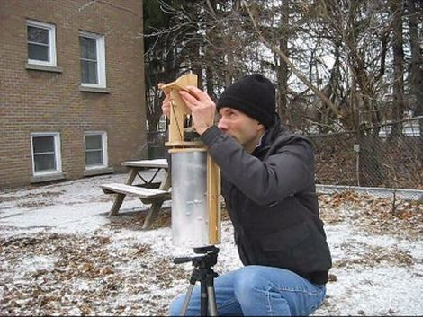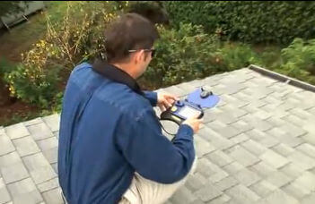
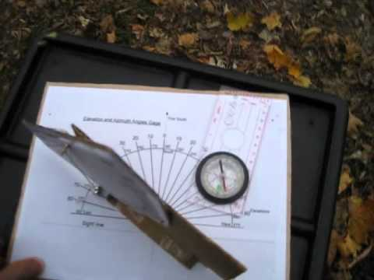

Competency Standard B: Develop basic Solar PV System design

Overview: This competency standard covers the skills and knowledge required to calculate load, select panels, determine backup time, assess working schedule of load and workout of capacity of devices.

Competency Units | Performance Criteria
B1. Calculate load for solar PV system design | Trainee will be able to:  - Enlist the No. of appliances  - Measure the PV system load  - Calculate the PV system load  - Record the PV system load
B2. Assess working schedule of load | Trainee will be able to:  - Inquire the load duty hours from customer  - Determine the peak load hours  - Observe peak sun hours
B3. Select Panels | Trainee will be able to:  - Select the type of PV panel  - Determine the capacity of PV solar panel  - Select number of PV solar panel
B4. Determine backup time | Trainee will be able to:  - Estimate the required backup time of load  - Estimate the capacity of battery bank  - Select the types of batteries for backup
B5. Draw basic design of solar PV System | Trainee will be able to:  - Workout capacities of devices  - Sketch a diagram as per requirements  - Get the design approve by the client

Knowledge & Understanding

The candidate must be able to demonstrate underpinning knowledge and understanding required to carry out the tasks covered in this competency standard. This includes the knowledge of:

- Basic concepts of designing
- Types and uses of electrical appliances
- Types and uses of various Solar PV systems
- Knowledge of all electronics, electrical and mechanical symbols
- Basic calculations (Addition, subtraction, division and multiplication)
- Series and Parallel circuits
- Basic definitions of current and electric circuits
- Solar PV system installation

Critical Evidence(s) Required

The candidate needs to produce following critical evidence(s) in order to be competent in this competency standard:

- Define Electricity, resistance and ohms law
- Randomly asked at least three electronics symbols and four electrical
- Calculate the load for a given electric appliances
- Calculate daily power consumption based on design
- Determine backup time for the given load
- Calculate no of solar panels for a given load
- Calculate battery bank for given backup time
- Types and uses of various drawing tools
- Explain schematic diagram with examples

Important points

- Be careful about shadow directions and its movements
- Understand any future developments around the location
- Basic concepts of electricity and electronics
- Complete data of survey must be kept in view while designing
- Design must be endorsed by the client once drafted
- Schematic diagram must be kept in view for designing

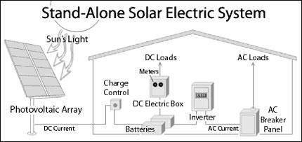

Competency Standard C: Interpret job document

Overview: This competency standard covers the skills and knowledge required to prepare checklist for the job, interpret schematic diagram, record the data and prepare log sheet for general maintenance.

Competency Units | Performance Criteria
C1. Prepare checklist for job | Trainee will be able to:  P1. Prepare list of material required  P2. Prepare list of tools required  P3. Prepare list of equipment required
C2. Interpret schematic diagram | Trainee will be able to:  P1. Read schematic diagram of wiring  P2. Read schematic diagram of civil work  P3. Read schematic diagram of mechanical work
C3. Record the data | Trainee will be able to:  P1. Collect the data  P2. Enlist the data  P3. Prepare report
C4. Prepare log sheet for general maintenance | Trainee will be able to:  P1. Prepare schedule of routine maintenance  P2. Identify the activities for conducting routine maintenance  P3. Prepare list of tools for routine maintenance

Knowledge & Understanding

The candidate must be able to demonstrate underpinning knowledge and understanding required to carry out the tasks covered in this competency standard. This includes the knowledge of:

- Basic electrical symbols
- Basic electronics symbols
- Types of basic wiring diagrams
- Basic computer operations
- Types and uses of various drawing tools
- Methods of recording data

Critical Evidence(s) Required

The candidate needs to produce following critical evidence(s) in order to be competent in this competency standard:

- Draw symbols for three given electrical components of assessors choice
- Draw symbols for three given electronics components of assessors choice
- Prepare a list of required tools and equipment for the given job

Important points

- Perform proper documentation complete in all respects
- Always use standard symbols
- Keep the design in view always while interpreting

Competency Standard D: Install Solar PV System

Overview: This competency standard covers the skills and knowledge required to arrange required tools and equipment, perform PV test, erect the mounting structure, fix PV modules and connect the PV modules as per circuit diagram.

Competency Units | Performance Criteria
D1. Arrange required tools and eqipment | Trainee will be able to:  P1. Collect the required tools and equipment  P2. Check physical status of tools and equipment  P3. Perform transportation of tools and equipment  P4. Manage safe storing of tools and equipment
D2. Perform PV test | Trainee will be able to:  P1. Conduct short circuit current test  P2. Conduct open circuit voltage test
D3. Erect the mounting structure | Trainee will be able to:  P1. Assemble the structure parts  P2. Fix mounting structure  P3. Adjust angles of the mounting structure
D4. Fix PV modules as per circuit design | Trainee will be able to:  P1. Install PV module on the mounting structure  P2. Verify angle of the PV module with the help of angle finder/meter  P3. Ensure shadow overlapping
D5. Install Battery Bank | Trainee will be able to:  P1. Arrange batteries with accessories as per requirements  P2. Fix battery bank in the racks  P3. Make parallel series strings for batteries, as per circuit design
D6. Install invertor / charge controller / variable frequency drive (VFD) | Trainee will be able to:  P1. Arrange invertor and charge controller in variable frequency drive (VFD)  P2. Fix invertor and charge controller in variable frequency drive (VFD)  P3. Ensure fixation as per circuit design
D7. Install Solar PV Pumps | Trainee will be able to:  P1. Arrange Solar pumps as per desired capacity  P2. Fix Solar pumps  P3. Ensure fixation of Solar pumps as per circuit design
D8. Connect the PV modules as per circuit design | Trainee will be able to:  P1. Make strings as per circuit design  P2. Make arrays as per circuit diagrams  P3. Connect arrays with junction boxes

Knowledge & Understanding

The candidate must be able to demonstrate underpinning knowledge and understanding required to carry out the tasks covered in this competency standard. This includes the knowledge of:

- Installation related tools and equipment
- Types of PV panels
- Mounting materials
- Installing electronics Components
- Types of mounting
- Types of solar pumps and their capacities
- Uses of installation tools
- Effect of shadows on PV Panels
- Effect of dust and moisture on PV Panels
- Types of solar PV systems (On/off grid, with and without back up, stand alone,)
- Net metering (Smart meters)

Critical Evidence(s) Required

The candidate needs to produce following critical evidence(s) in order to be competent in this competency standard:

- Identify required tools for the given job
- Assemble the mounting structure
- Install PV panel on the mounting structure
- Fix the mounting structure for maximum output power
- Verify PV module specifications test (short circuit current & open circuit voltage test)
- Interconnect the battery bank as per requirement
- Interconnect the battery bank, PV module and utility with invertor for a desired output load
- Configure the invertor according to the given job
- Interpret the circuit diagram
- Prepare solar PV array for a water pump and explain it
- Interconnect the PV array, VFD and pump
- Configure the VFD
- Explain Solar PV system

Important points

- Take care of proper insulation at all stages
  - Cables
  - Accessories
  - Tools
- Ensure proper tightening of all nut bolts
- Ensure proper levelling of all items, as per standards
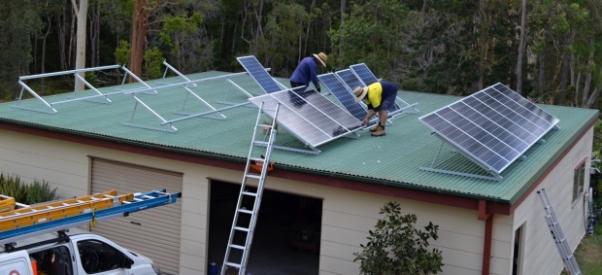

Competency Standard E: Perform wiring of Solar PV System

Overview: This competency standard covers the skills and knowledge required to interpret wiring diagram, lay cables, perform wiring test, carryout battery test, connect PV system with battery and invertor, , configure invertor and verify proper working of the system through load execution test.

Competency Units | Performance Criteria
E1: Interpret wiring diagram | Trainee will be able to:  P1. Collect the wiring diagram and layout from job documents  P2. Identify paths and marking for wiring
E2: Connect the PV modules as per circuit diagram | Trainee will be able to:  P1. Interconnect the strings to make arrays  P2. Insulate all the arrays as per standard  P3. Combine all the arrays through combiner box
E3: Lay Cables | Trainee will be able to:  P1. Install conduits for cables  P2. Lay cables through the conduits  P3. Connect the cables to the control and safety boxes
E4. Perform wiring test | Trainee will be able to:  P1. Perform continuity test  P2. Perform polarity test  P3. Perform earth test
E5. Carry out battery test | Trainee will be able to:  P1. Perform specific gravity test  P2. Perform internal short circuit test  P3. Perform terminal voltage test  P4. Check terminal for carbon contents  P5. Perform battery bank polarity test
E6: Interconnect the PV system | Trainee will be able to:  P1. Connect the battery bank to the inverter / charge controller through safety circuits  P2. Connect the PV modules to the inverters / controllers through safety circuits  P3. Connect the invertor with the input A.C source  P4. Connect the load to the invertor through safety circuit
E7: Configure the invertor / charge controller | Trainee will be able to:  P1. Interpret the invertor manual  P2. Inquire the customers / site requirements  P3. Set the parameters as per requirement

Knowledge & Understanding

The candidate must be able to demonstrate underpinning knowledge and understanding required to carry out the tasks covered in this competency standard. This includes the knowledge of:

- Types of wires
- Sizes of wires
- Colour scheme
- Types of wiring joints
- Types of insulating materials
- Wiring tools and their uses
- Techniques of Earthling
- Safety precautions
- Uses of PPE
- Various types of wiring tests

Critical Evidence(s) Required

The candidate needs to produce following critical evidence(s) in order to be competent in this competency standard:

- Differentiate between various sizes of cables
- Draw wiring diagram of a Solar PV system as per given load
- Prepare a list of wiring materials, for a given circuit diagram
- Interconnect protection devices with solar PV system
- Make any one of the following joint as decided by assessor
  - “Tee – joint” and insolate it as per standard
  - “Married – joint” and insolate it as per standard
  - “Britannia – joint” and insolate it as per standard
  - Western Union – Joint and insolate it as per standard
  - Straight Joint and insolate it as per standard

Important points

- Always wear related personal protective equipment
- Ensure polarities of Solar PV system
- All wiring must be properly insulated
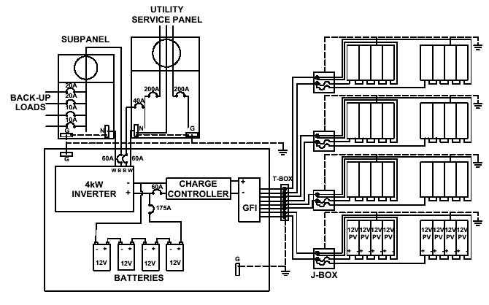
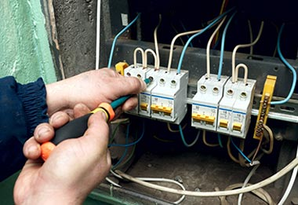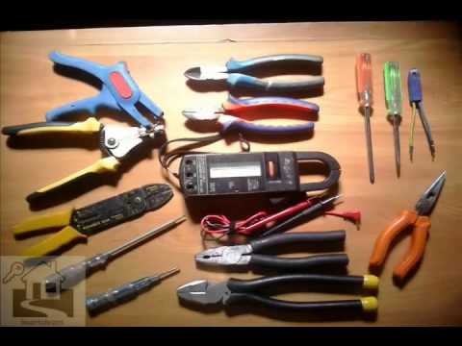

Competency Standard F: Troubleshoot Solar PV system

Overview: This competency standard covers the skills and knowledge required to Diagnose the fault, Identify solution of the faults, rectify the faults, carryout post rectification function test and finally perform wiring test.

Competency Units | Performance Criteria
F1: Diagnose the fault | Trainee will be able to:  - Check invertor for fault code  - Verify safety circuits  - Check status of wiring  - Verify status of battery  - Check status of PV Panels  - Identify nature of the fault (Hardware or software)  - Diagnose the cause of fault  - Document the fault
F4: Identify solution of the faults | Trainee will be able to:  - Trace out solution of fault code with the help of manual  - Estimate cost of rectification  - Report the fault to the concerned persons
F5: Rectify the faults | Trainee will be able to:  - Reset the software for rectification  - Arrange the required tools and equipment  - Arrange the required material and components  - Repair faulty component / equipment  - Replace faulty component / equipment  - Refer irreparable / un-replaceable faults to the concerned lab
F7. Carryout post rectification function test | Trainee will be able to:  P1. Re connect the system with the load  P2. Verify function of the system on full load  P3. Document the services as per instructions  P4. Clean and pack the store as per sop
F8. Perform wiring tests | Trainee will be able to:  P1. Perform continuity test  P2. Perform polarity test  P3. Perform earth test  P4. Rectify the problem

Knowledge & Understanding

The candidate must be able to demonstrate underpinning knowledge and understanding required to carry out the tasks covered in this competency standard. This includes the knowledge of:

- Types and uses of various testing equipment
- Diagnostic Procedures
- Use of manual
- Costing of rectification
- Use of invertor user interface software
- Types of faults in Solar PV system
- Various diagnostic tests and techniques
- Standard operating procedure for troubleshooting

Critical Evidence(s) Required

The candidate needs to produce following critical evidence(s) in order to be competent in this competency standard:

- Perform one of the following tests as per instruction of assessor
- Continuity test
- Earth test
- Polarity test
- Identify faulty module in array
- Sort out fault from a given fault code with the help of manual
- Replace the faulty protective devices

Important points

- Follow procedure and sequence of finding faults
- Isolation of system must be ensured
- Ensure tagging out of faulty devices and equipment

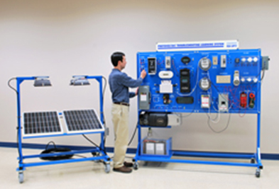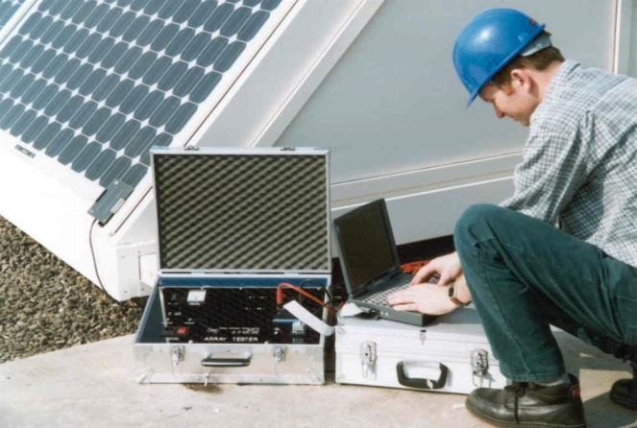

Competency Standard G: Maintain Solar PV system

Overview: This competency standard covers the skills and knowledge required to prepare check list for maintenance, follow routine maintenance log sheet, maintain Solar PV modules and perform post verification function of the system.

Competency Units | Performance Criteria
G1. Prepare check list for maintenance | Trainee will be able to:  - Prepare list of tools and instruments for maintenance  - Prepare list of materials for maintenance  - Prepare list of activities for maintenance
G2. Follow routine maintenance log sheet | Trainee will be able to:  - Collect maintenance log sheet  - Arrange required tools / instruments for maintenance  - Perform activities as per schedule  - Place equipment after maintenance as per SOP
G3. Maintain Solar PV modules | Trainee will be able to:  - Arrange cleaning materials  - Wash the panels as per instructions (Avoid washing during peak sun hours).  - Check connections and joints of solar PV modules  - Check the physical and mechanical health of modules as per standard  - Adjust the seasonal tilt angle
G4. Maintain invertor / Charge controller / Protection circuits | Trainee will be able to:  P1. Arrange servicing equipment  P2. Check the status of cooling fans  P3. Check input output terminals of invertors  P4. Perform servicing with electrical blower  P5. Maintain connection status as per standards
G5. Maintain battery bank | Trainee will be able to:  P1. Clean terminals of battery with sand paper  P2. Maintain level of electrolytes  P3. Maintain gravity of electrolytes  P4. Maintain battery connections  P5. Apply grease to terminal to avoid corrosion / sulphation  P6. Verify the operations of battery bank
G6. Perform post verification function of the system | P1. Switch on the system  P2. Observe display reading of inverter / charge controller  P3. Perform full load test  P4. Prepare the report of maintenance activities performed

Knowledge & Understanding

The candidate must be able to demonstrate underpinning knowledge and understanding required to carry out the tasks covered in this competency standard. This includes the knowledge of:

- Procedure of inspection
- Service procedures
- Panel washing techniques
- Uses of washing materials
- Appropriate timings of service
- Types of corrosions
- Procedure of battery maintenance and level of electrolyte
- Types of batteries and their maintenance processes
- Difference of service materials
- Use of testing instruments
- Maintenance techniques of invertor / charge controller / VFD

Critical Evidence(s) Required

The candidate needs to produce following critical evidence(s) in order to be competent in this competency standard:

- Prepare a maintenance schedule as per standard
- Determine the level and gravity of electrolyte solution in battery bank
- Perform cleaning procedure of solar PV modules
- Perform cleaning procedure for invertor

Important points

- Post maintenance test must be performed for proper operation of system
- Housekeeping must be adopted at every stage
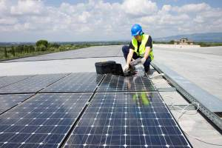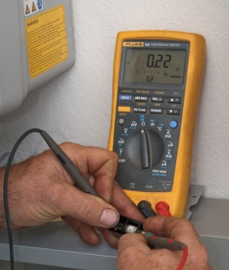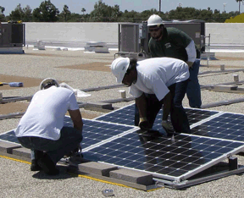

Competency Standard H: Adopt safety precautions

Overview: This competency standard covers the skills and knowledge required to protect from all security threats by ensuring personal saftey, workplace safety prepare and saftey of all tools and equipment.

Competency Units | Performance Criteria
H1. Ensure Personal saftey | Trainee will be able to:  P1. Arrange PPEs as per requirements  P2. Wear proper PPE as per nature of job  P3. Store PPEs at appropriate place after use  P4. Ensure availability of first aid box
H2. Ensure workplace safety. | Trainee will be able to:  P1. Ensure cleaning of workplace properly  P2. Avoid hazardous (electric / chemical) by adopting safety precautions  P3. Ensure availability of emergency exit  P4. Ensure lighting and ventilation  P5. Ensure availability of Firefighting equipment  P6. Report to the concerned immediately in case of emergency  P7. Ensure safe access to the system
H3. Ensure saftey of tools and equipment | Trainee will be able to:  P1. Ensure insulation of tools and equipment  P2. Store safely tools and equipment  P3. Clean tools on a regular basis as per schedule

Knowledge & Understanding

The candidate must be able to demonstrate underpinning knowledge and understanding required to carry out the tasks covered in this competency standard. This includes the knowledge of:

- Types of physical hazards
- Types of chemical hazards
- Types of electrical hazards
- Differentiate between physical, chemical and electrical hazards
- Treatments of various hazards
- Types and use of PPEs
- Types of Risks
- Risk Management
- Risk assessment
- Monitor and risk control measures
- First Aid Treatment
- Use of safety equipment
- Importance of tools safety
- Reporting risks and hazards

Critical Evidence(s) Required

The candidate needs to produce following critical evidence(s) in order to be competent in this competency standard:

- Prepare a list of PPEs
- Demonstrate the use of at least one of the PPEs in front of assessor as per assessors directions
- Perform first aid treatment against electric shock
- Explain safety procedure at workplace
- Differentiate between safe and unsafe tools

Important points

- Focus on personal tasks
- Personal Safety first
- Ensure safety of co-workers
- Health of PPEs must be ensured
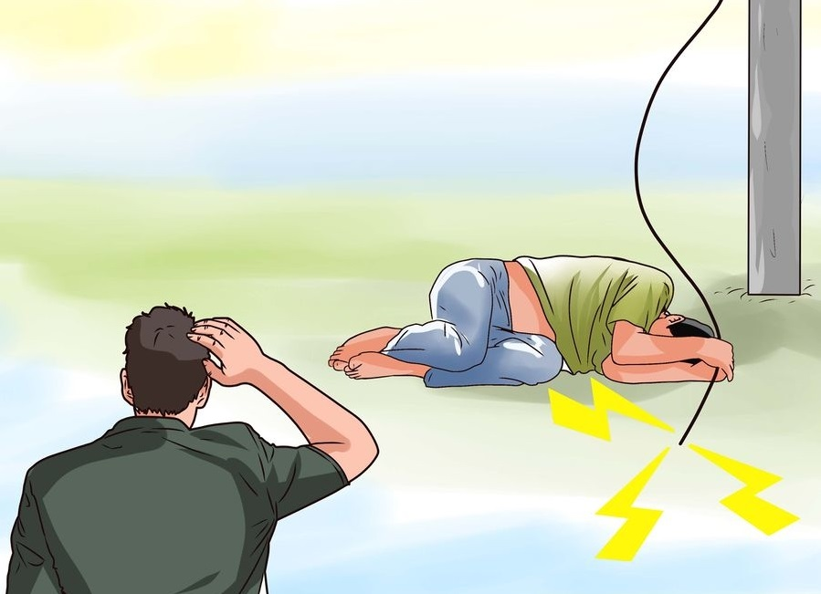
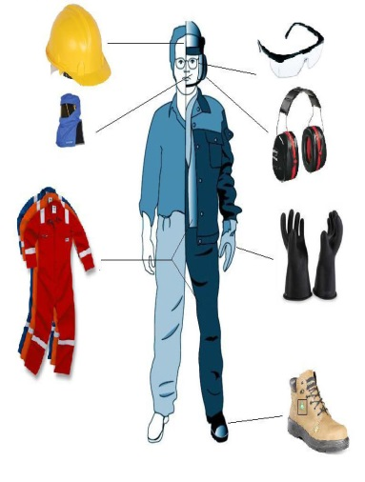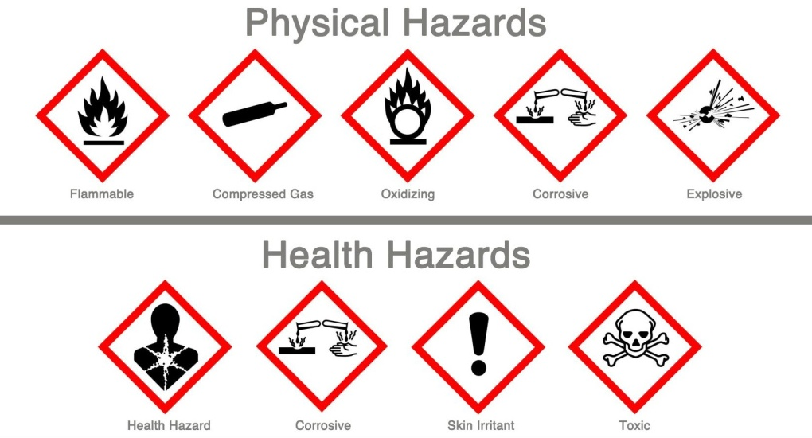

Competency Standard I: Develop basic professional skills

Overview: This competency standard covers the skills and knowledge required to develop basic computer operating skills, develop basic communication skills, develop basic marketing skills.

Competency Units | Performance Criteria
I1. Develop basic computer operating skills | Trainee will be able to:  - Perform Microsoft basic commands in MS word  - Open File  - Format a file  - Font (Type/size/bold/Italic)  - Header Footer  - Page number  - Insert pics/table/hyperlink  - Save a File  - Save a folder  - Perform basic commands in Microsoft MS Excel  - Open a worksheet  - Sum functions  - If functions  - Basic calculations  - Table and graphs  - Save a worksheet/folder  - Prepare Microsoft power point presentation by using basic commands  - Make a power point file  - Insert pics/table/hyperlink  - Design a theme for slides  - Save a power point file  P4. Perform browsing on the internet as per needs  P5. Perform research online on new trends in the market with the help of internet
I2. Develop basic communication skills. | Trainee will be able to:  - Negotiate with a client to understand the demand  - Plan product supply as per clients requirements  - Set price(s) according to clients requirements  - Communicate the plan to the client  - Take feedback from client on understanding of the exact job with timeline and cost
I3. Develop basic marketing skills | Trainee will be able to:  - Present a design to the client as per requirement  - Finalize the business deal  - Purchase the equipment/tools and consumables as per agreed design  - Adopt correct means of transportation  - Select promotional means, according to target needs of clients
I4. Identify needs of the market. | Trainee will be able to:  - Analyse upcoming market trends.  - Develop Professional network.  - Demonstrate behavioural skills.  - Develop sound interpersonal skills  - Develop new designs.
I5. Follow Environmental, Health and Safety standards. | Trainee will be able to:  - Follow Health and Safety Rules  - Ensure environmental safety  - Ensure compliance of net metering policy  - Ensure workplace safety by following safety standards  - Ensure safety while operating wires and electricity.  - Store all tools and equipment properly in a safe area.

Knowledge & Understanding

The candidate must be able to demonstrate underpinning knowledge and understanding required to carry out the tasks covered in this competency standard. This includes the knowledge of:

- Basic computers
- Importance and uses of MS Word
- Importance and uses of MS Excel
- Importance and uses of MS Power Point
- Basic concepts of communication
- Seven Cs in communication
- Basic concepts of marketing
- Trends of markets (Demand and supply etc.)
- Knowledge of 4Ps

  - Product
  - Price
  - Promotion
  - Placement

- Service Product knowledge for Solar PV System
- Net metering Policy of Pakistan
- Net metering laws of Pakistan
- Pakistan’s Feed in Tariffs (FITs)
- Pakistan's renewable power policy and regulatory frameworks
- The Management of Health and Safety at Work Regulations 1992.
- Environment Protection Agency.
- National Electric Power Regulatory Authority (NEPRA)
- Performance Standards (Generation) rules 2009
- Professionalism (meaning, attitude, output, timely delivery, networking)
- Importance of trends and market research.
- Significance of workplace cleanliness.
- Handling of Electric Supply and Appliances
- Process to handle emergency situations.

Critical Evidence(s) Required

The candidate needs to produce following critical evidence(s) in order to be competent in this competency standard:

- Performed role playing properly as Buyer and Seller and they will negotiate to finalize a realistic business deal
- Explain net metering Policy of Pakistan and its laws
- Describe Pakistan’s Feed in Tariffs (FITs)
- Write note on key features of Pakistan's renewable power policy and regulatory frameworks
- Describe functions of National Electric Power Regulatory Authority (NEPRA)
- Make a list of material which can catch fire
- Explain the importance of health and safety
- Brief about types of hazards at workplace

Important points

- Must be conscious about health and safety measures at work place
- Can communicate professionally with outsiders and within organisation
- Can download new laws and policies from internet
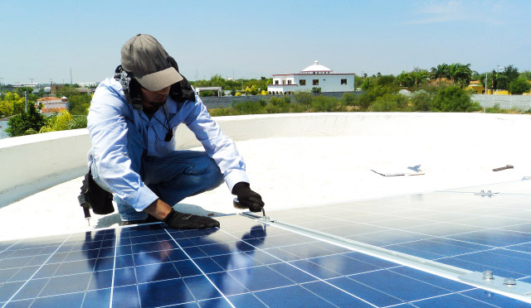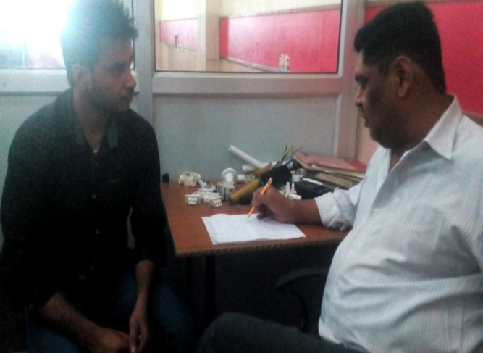

COMPLETE LIST OF TOOLS AND EQUIPMENT

List of Tools
Sr. # | Description | Specifications
 | Combination plier | 180mm
 | Long nose Plier
 | Cable Cutter | 180mm
 | Cable Cutter | 12"
 | Cable Cutter | 18"
 | Claw Hammer | 1 pound
 | Hammer | Cross pin 200g
 | Screw Driver Set
 | Mini Screw Driver Set
 | Screw Driver Set (metal head type)
 | Hammer | 1 kg
 | Cable Knife/paper cutter
 | Wire Striper/insulation remover
 | Soldering Iron with Stand | 60W , 80W, 120W
 | Sucker | For Soldering Iron
 | Tool box | 18"
 | Bench vice | 6"
 | Angle Grinder | 5"
 | Mini Drill machine | for PCB drilling with bits
 | Drill Machine Rotary Hammer
 | Drill Machine | Reverse Forward 13mm
 | Cordless Drill machine | 18V
 | Extension board | multi Sockets With 10 Meters Wire
 | Chisel | 8"
 | Chisel | 12"
 | Torpedo level / spirit level | Different size
 | Compass
 | Adjustable Wrench | 8"
 | Adjustable Wrench | 12"
 | Richet Set | 72 Pcs
 | Spanner Set | 12 pcs
 | Torque wrench with deep sockets | Small 12"
 | Pipe wrench | 16"
 | Welding plant With holder and lead | 300 Amp
 | Thimble press | 16mm to 240mm
 | Electric blower
 | Heat gun
 | Measuring Tape | 3m
 | Measuring Tape | 5m
 | Measuring Tape | 50m
 | Hack Saw With blades
 | File Set | Small size
 | File Set | large Size
 | L-key Set
 | Fish Tape | 100ft
 | Wood Saw
 | Hole Saw For panel | 25mm
 | Hole Saw For panel | 50mm
 | Hole Saw For panel | 70mm
 | Wooden Bit Set
 | Twist Drill bit Set | HSS 0.5mm to 16mm
 | Tap and Die Set | 32 pcs Set
 | Hand Tin Scissors | 18"
 | Pipe vice with Stands | 4"
 | Scissor | 8" for fabric
 | Tuser | 6", 8", 12"
 | Gas Cutting torch with Oxygen And LPG Cylinders | Oxygen LPG & Oxy Gas Cutting Torch 520mm
 | Magnetic wristband for holding bits and parts
 | Hot Melt Glue Gun 20W | 20 watt with 50 glue Sticks
 | Tool Belt | 18 pcs

List of Equipment
Sr. # | Description | Specifications
 | Digital Oscilloscope | Tektronix TDS 3000
 | Digital Oscilloscope | Tektronix TBS 2000
 | Synchronizing meter /smart energy meter | For Grid Tied
 | DC Power Supply | Tektronix keithly 2268
 | Phase Sequence Meter | kyoritsu kew 8031F
 | Function Generator | Tektronix AFG 1000
 | Clamp On meter | kyoritsu 2432
 | Clamp on meter | Uni-T ut203
 | DC volt Meter Digital | 0 to 250 VDC 10Amp panel type Small Size
 | DC ampere Meter Digital | 100 amp with CT(current Transformer)
 | AC volt Meter Digital | 0 to 50 Amp 0 to 600 VAC panel type Small
 | AC ampere Meter Digital | 0 to 50 Amp 0 to 600 VAC panel type Small
 | Digital multi meter | Tecpel 8062
 | Analog multi meter | Sunwa
 | megger meter/insulation tester | Analog
 | megger meter/insulation tester | digital MIT 300
 | Earth Tester | Digital
 | Micro meter | Digital
 | Vernier Caliper | Digital
 | Watt Ampere meter For Solar | thermodin System 130 amps
 | Tachometer | Digital
 | Tachometer | Analog
 | Frequency Meter | AC 80-300V/30-70HZ 3 in1 LCD Time Voltage
 | Hydro meter | Digital
 | Hydro meter | Analog
 | Variable AC power Supply | Super world 1KVA
 | Battery tester | Original Launch BST-460 6V & 12V Battery Tester for Battery
 | battery level indicator | DC 3.5-30V Mini LED Battery level voltage monitor meter indicator
 | Watt meter | EU Plug-In Electricity Power Energy Meter Monitor Analyzer KWh Watt Volt Amps
 | Hour Meter | digital 220v
 | Hour Meter | digital 12v
 | Energy meter | Digital single phase
 | Lux meter | Digital Light Meter,Tester200,000 LUX,FC Photo Camera
 | Inductive and Capacitive meter | digital Hp-4070L
 | Temperature gun | Non-Contact IR Infrared Digital Temperature Temp Thermometer Laser Point Gun
 | Temperature controller | With thermocouple
 | Digital Camera | Sony Cyber-shot DSC-H300 35x Optical Zoom Digital Camera - Black
 | digital angle Finder | Sprit Level type
 | Stud Finder | Zircon
 | PC | HP COMPAQ,COR i7-1TB-8GB-3.40 GHZ-2600 QUAD CORE-WIN 7 P1GB GRAPHICS-DVD-RW
 | Printer | HP LaserJet P1102
 | Scanner | HP
 | Multimedia projector | Sony VPL-DX147 3200 Lumens XGA
 | Charge Controller | PWM 15 amp
 | Charge Controller | PWM 40 amp
 | Charge Controller | MPPT 20 amp
 | Charge Controller | MPPT 50 amp
 | Solar Hybrid Inverter On/Off Grid | MPPT 10 kW 3 phase
 | Solar Hybrid Inverter | MPPT 5 KVA
 | solar Hybrid Inverter | MPPT 3 KVA
 | solar Hybrid Inverter | PWM 3 KVA
 | Inverter | 1500 watt sine wave
 | Inverter | 1000 watt sine wave
 | Submersible Solar pumps | 3hp And 5hp 3phase
 | VFD | 5 HP 3 phase for solar pump
 | Inverter | 500 watt Sine wave
 | DRY Batteries | 200amp 12 v
 | DRY Batteries | 12amp 12 v
 | DRY Batteries | 100amp 12 v
 | DRY cell | 2V 200amp
 | Solar panel | polycrystalline 250 watt YINGLI solar
 | Solar panel | polycrystalline 150 watt
 | Solar panel | polycrystalline 100 watt
 | Solar panel | monocrystalline 100 watt
 | Solar panel | Thin film 50 watt
 | Solar panel | monocrystalline 50 watt
 | Solar panel | monocrystalline 20 watt
 | Solar panel | monocrystalline 10 watt
 | Solar panel | Polycrystalline & Monocrystalline 5 watt
 | Solar Photovoltaic Cells | 3 watt
 | Battery Charger | 20 ampere Transformer Less
 | DC power Supply | 12 to 24 volt Omron
 | DC solar Pump | 24VDC 400 watt China
 | Solar panel Stands | For 250 watt
 | Infrared camera | Flir instruments
 | Solar power meter | Tes-1333r solar power meter
 | Irradiance meter | TN-2340
 | 3 phase inverter for solar water pump | 5KVA
 | 3 phase inverter for solar water pump | 7KVA
 | Solar installation tester | SEAWARD PV150
 | Solmetric pv analyzer | PVA 1000 PV analyzer kit

List of Personal Protective Equipment
Sr. # | Description | Specifications
 | First AID Box
 | Fire Extinguisher Cylinder | Co2- 5 Kg
 | Fire Blanket
 | Fire Bucket
 | Safety Gloves | Leather
 | Safety Gloves | Rubber for 1000 volt
 | safety googles | White
 | Safety Helmet | Yellow
 | Safety Helmet | White
 | Safety mask
 | Formal Uniform For Work
 | Safety Shoes
 | Safety Belt
 | Ear Protector

List of Trainers Kit
Sr. # | Description | Specifications
 | EPH3 professional photovoltaic trainer | Lucas Nulla
 | IGBT chopper inverter trainer | Labvolt mode No 8857-1
 | AC/DC training system | Labvolt mode No 3351
 | VFD training system | Labvolt mode No 3356
 | solar power training system | Labvolt mode No 8010-2
 | lead acid batteries training system | Labvolt mode No 8010-4
 | Dc fundamental 1&2 | Labvolt mode No 91001-20
 | Ac fundamental 1&2 | Labvolt mode No 91003-2
 | Semiconductor devices | Labvolt mode No 91005-2
 | Transistor amplifier | Labvolt mode No 91006-2
 | Transistor feed back | Labvolt mode No 91008-24
 | Power supply regulation | Labvolt mode No 91009-25
 | FET fundamental | Labvolt mode No 91010-2
 | Thyristor and power control | Labvolt mode No 91011-2
 | Operational amplifier | Labvolt mode No 91012-2
 | Power transistor and GTO thyristor | Labvolt mode No 91013-2
 | Starter usb for pic | Mikro electronica
 | Pic kit2 starting kit | MP Lab

